Climate influences flowering time but not natural selection in a perennial herb
INTRODUCTION
Climate change has important effects on the abundance and distribution of species, as well as on ecosystem functioning (REF). It also affects the seasonal timing of life cycle events, and differential effects might lead to mismatches between interacting species (REF). While such short-term, plastic, responses are relatively well documented, we know less about how climate change influences natural selection, the covariation between traits and fitness, and to what extent populations are able to respond evolutionary to altered selection (e.g. MacColl 20xx, REF; reviewer + Soay sheep). In particular, we know little about to what extent observed patterns of trait changes in response to climate change, are the result of changes in trait expression (plasticity) vs. evolutionary responses to changes in natural selection.
In many environments, the effects of climate change on the timing of life cycle events are crucial to the survival of organisms. Timing constitutes the main way in which an organism can modify its interactions with the surrounding abiotic environment as well as with other species. For example, in plants resource availability and abiotic conditions, like temperature, humidity and light availability, are important determinants of optimal timing of flowering, but also interactions with pollinators and herbivores constitute important sources of selection. Abiotic and biotic factors can influence both the timing of a given genotype in a given year (ref …), and natural selection on timing. For example, higher temperatures and a longer growing season might lead both to a plastic response in terms of an earlier start of growth, and to selection for a lower sensitivity to temperature increases in spring (changes in thermal reaction norms), i.e., counter-gradient responses. … While studies with many types of organisms have documented strong effects of climate on the timing of different life cycle events (REF), the effects on natural selection on timing, and how these are related to plasticity, are much less known (but see ….).
To examine how climate simultaneously influences phenotypic responses and selection, we need not only temporally well replicated estimates of trait values and potential drivers, but also yearly estimates of phenotypic selection. In this study we use a long-term (22 years) data set for a population of the perennial herb Lathyrus vernus to explore how trait expression and phenotypic selection on flowering time vary among years. Because the study species is long-lived and the turn-over of individuals within the study population is very low, changes in flowering phenology can be assumed to the result of phenotypic plasticity. Previous studies with this species … Ehrlén and Munzbergova 2009 … We recorded flowering times and fitness of xx-xxx individuals in each of 22 years and estimated selection gradients for flowering phenology. We addressed the following questions: (1) Does flowering time vary among years in response to spring temperature, (2) Does the direction and strength of phenotypic selection on flowering time vary among years? (How much? Is there a trend? Are patterns equal for indirect (selection differentials) and direct (selection gradients) selection?), and (3) Is variation in phenotypic selection among years related to spring temperatures or mean flowering phenology?
MATERIALS AND METHODS
Study system
The study was carried out in a population of Lathyrus vernus … Tullgarn area, SE Sweden coordinates, in a deciduous forest … from 1987 to 2017. …
Lathyrus vernus is a long-lived forest herb. The average conditional life span of flowering individuals has been estimated to 44.3 years and the age at which individuals start to reproduce in this population is more than 10 years (REF). Lathyrus vernus flowers early in the season before the canopy of deciduous trees develops. Flowering phenology is closely correlated with vegetative phenology (REF), and the shoots emerge from a subterranean rhizome a few weeks before flowering. Timing of flowering has been shown to be correlated with differences in fruit set and this pattern seems to be influenced by both resource and pollen availability (REF). Timing of flowering is also associated with differences in antagonistic interactions with pre-dispersal seed predators and ungulate herbivores (REF).
… Heritability of flowering time …?
Seed production … dispersal … germination … growth … reproduction … dormancy … frequency of flowering … Individuals do not flower in all years but frequently skip flowering
The long life span of L. vernus and an observed low turnover of individuals in the study population means that, in spite of the long duration of the study, observed variation in trait distributions among years is likely to be mostly the result of phenotypic plasticity, while changes in the genetic structure of the population are likely to have played a minor role.
Data collection
Data was collected in 22 years, 1987 – 1996 and 2006 – 2017. … Study plot … new plot and new individuals in 2006, adjacent to the old plot, i.e., new individuals but similar environmental conditions … permanent markings of all flowering individuals using … flags, individuals followed through years … recordings starting early in the season … every fourth to fifth day – bud size, flower opening … flower number … fitness, vegetative size. … In some of the years, first flowering day (FFD) was assigned to each individual by recording the state of the most advanced bud or flower at each recording. For just open flowers, FFD was set to the day of recording. For buds, FFD was estimated to occur one or several days later based on the size and shape of the largest bud. For open flowers, FFD was estimated to have occurred one or several days earlier based on the color and degree of wilting. For flowers that were not considered to have opened recording days, we used the mean of the estimated FFD before and after flower opening. In other years, … Daily recordings of a subset of flowers in some of the study years show that this method often assigns the correct FFD and that the estimate never differs with more than one day from the actual date. … non-flowering …
Weather data was … mean of two stations?
Data management
Imputation (note only in cases where bud size was not recorded) … Flowering time for individuals that were grazed before flower opening .. the invisible fraction
Weather parameters … “Spring temperature” .. other parameters (do we need to mention all?)
Precipitation data was missing in February 1988, June 1991, February and October 1992. In these cases, missing values of precipitation for each date were substituted by the mean of all years for that particular date.
Calculation of GDD and GDH? …
Calculation of position (mean FFD, date when 10/20%, 80/90% of plants are flowering, first and last FFD, SD, skewness) and duration of flowering season (duration = range of FFD, kurtosis?)
Statistical analyses
Plant ID …
Selection differentials - define (estimates of phenology and flower number (size?)) + stabilizing (quadratic) selection differentials
… A main caveat with phenotypic selection gradients based on correlations between traits and fitness is that they may not reflect causal relationships. Environmental heterogeneity may confound estimates of selection in terms of a covariance between focal traits and fitness. To decrease this problem, we will include condition variables in all analyses…. Flowering time is often correlated with plant resource state in terms of flower number (Hendry and Day 2005) or size (Forrest 2014)
Selection gradients - define (including flower number as a measure of resource state and reduce biases due to environmental covariance) + stabilizing and correlational gradients (adding the quadratic terms and the interaction term, multiply selection gradients by 2 as in Stinchcombe et al. 2008)
Yearly variation in weather, flowering time, selection on flowering time (selection differentials and selection gradients) – GRAPHS (main text or appendix)
Link among-year variation in flowering time to climatic conditions
Table 2: The main effect of year was not included as fitness was relativized within years prior to analysis. (same for Table 3 with the main effects of variables spring temp / position / duration).
Link among-year variation in selection gradients to climatic conditions, summarized by (a) spring temperature (mean temperature during April and May), (b) position of flowering season (in terms of mean (10/20%, 80/90%) FFD, MFD and LFD) (perhaps it is worthwhile to also use SD and skewness to characterize the spring climate!?), and (c) duration of flowering season (e.g. in terms the mean duration of individual flowering times (not available for all years) or population estimates such as 90% FFD – 10% FFD)*, kurtosis?.
Mean temperature during April and May … motivation … other measures tested but none provided a better fit (how much about this?) …
Using mean FFD within the population as a measure of yearly environmental conditions …
Trends in mean values of FFD and selection estimates over the study period!? – Detrended values?
RESULTS
We found considerable variation in spring temperature, flowering time and selection on flowering time among the 22 study years (Fig. 1). Mean daily temperature in April and May ranged from 6.4 to 9.7 ºC with a mean of 8.3 ºC, first flowering day ranged from 48.1 to 71.6 days from the vernal equinox, with a mean of 58.0 days from the vernal equinox, and selection gradient for first flowering day ranged from -0.8 to 0.1 with a mean of -0.3.
Flowering occurred significantly earlier in years with higher spring temperatures (Table 1A, Fig. 2A). Both the day when 10% of the plants had started flowering, the mean first flowering day and the day when 90% of the plants had started flowering were earlier in years with higher temperatures in April and May. Between the warmest and coldest springs of the study period (mean daily temperature April-May 9.7 vs. 6.4 ºC), the predicted differences in the position of the flowering season were 18.7 days for the day when 10% of the plants had started flowering, 17.3 days for mean first flowering day and 15.9 days for the day when 90% of the plants had started flowering. Spring temperature explained a very large part of the variation in the position of the flowering season (70-76%, Table 1A). The flowering season had a longer duration in years with higher spring temperatures (Table 1B, Fig. 2B). The number of days between the day when 10% of the plants had started flowering and the day when 90% of the plants had started flowering increased with higher temperatures in April. The predicted difference in the duration of the flowering season between the warmest and coldest springs of the study period (mean daily temperature April 3.6 vs. 8.4 ºC) was 9.1 days. Spring temperature explained 48% of the variation in the duration of the flowering season (Table 1B).
Both indirect and direct phenotypic selection on flowering time varied significantly among years (Table 2). Indirect selection was statistically significant in 17 years (Fig. S1, Table S1), while direct selection was statistically significant in 7 years (Fig. 1, Table S2). Selection differentials and gradients for first flowering day were almost always negative (i.e. both indirect and direct selection favored early flowering), except for 2 years where each of them were positive, although not significant (Table S1-S2). However, variation in phenotypic selection among years was neither related to spring temperature, nor to position or duration of the flowering season (Table 3, Fig. 3).
DISCUSSION
Our results show that flowering phenology in terms of first flowering date in this forest herb is strongly correlated with spring temperature, flowering being xx days earlier with a one-degree increase in mean temperature during April-May (or min vs. max). Phenotypic selection gradients varied significantly among years, from strongly favoring (?) early flowering in some years to … in other years. This variation in selection was, however, not linked to spring temperatures or mean flowering time within the population. Our results thus show that while spring temperature had strong effects on trait expression, it had no detectable effect on phenotypic selection on flowering time. … Provide no support for that we should expect evolutionary responses to changes in temperatures … other factors causing variation in selection on flowering time than those influencing phenotypic plasticity of the trait …
… flowering phenology in terms of first flowering date was strongly correlated with spring temperature, flowering being xx days earlier with a one-degree increase in mean temperature during April-May. … Other potential drivers examined … Explanatory power … Causal mechanisms … Other studies … Concluding remark
… Phenotypic selection gradients varied significantly among years, from strongly favoring (?) early flowering in some years to … in other years. … Other results for selection on flowering time … direction … among-year variation … Among-year variation in selection gradients in general … methodological concerns … implications … [Temporal variation in selection is important because it determines the overall direction and magnitude of selection, and because it may constrain adaptive evolution. Both the direction and strength of selection has been shown to vary geographically and among years, and in some systems temporal variation can be linked to climatic variation (e.g. Thompson 2005; Siepielski, DiBattista & Carlsson 2009).] … Empirical evidence suggest that selection estimates vary both spatially and over time within populations (cf. reviews)… Yet, the prevalence of temporal variation in selection have been questioned based on … Hadfield et al 2xxx). We also know very little about the causes of temporal variation in natural selection (but see Charmantier et al. 2008, …).]
… This variation in selection was, however, not linked to spring temperatures or mean flowering time within the population. … Implications … Consequences … Causes … Other selective agents – Not strongly linked to spring temperatures … Other studies … General about effects of (climatic) drivers on trait expression, selection on thermal reaction norms (can not be excluded – further studies needed), counter- and co-gradient patterns, other types of potential relationships .. Concluding remark
We conclude … CC vs. plasticity and selection …

Tables
Table 1: Results of linear models showing the effect of spring temperature on the position (A) and duration (B) of the flowering season of Lathyrus vernus in 22 study years. The position of the flowering season was defined by the day when 10% of the plants had started flowering (10% FFD), the mean first flowering day (Mean FFD), and the day when 90% of the plants had started flowering (90% FFD). The duration of the flowering season was defined by the number of days between the day when 10% of the plants had started flowering and the day when 90% of the plants had started flowering (N days 90-10% FFD).
Response variable | Predictor variable | Estimate |  | Std. error | t | Adj. R²
A) Position of the flowering season |  | -5.736 | *** | 0.807 | -7.11 | 0.702
10% FFD | Mean daily temperature April-May
Mean FFD | Mean daily temperature April-May | -5.307 | *** | 0.638 | -8.32 | 0.764
90% FFD | Mean daily temperature April-May | -4.889 | *** | 0.617 | -7.93 | 0.746
B) Duration or the flowering season
N days 90-10% FFD | Mean daily temperature April | 1.869 | *** | 0.417 | 4.48 | 0.476
***P < 0.001; **P < 0.01; *P < 0.05

Table 2: Phenotypic selection models testing for among-year differences in (A) indirect and (B) direct phenotypic selection on flowering time in Lathyrus vernus in 22 study years. Results are from linear models including the interaction first flowering day : year in order to assess among-year differences in (A) selection differentials and (B) selection gradients for first flowering day. In (B), number of flowers is included as a condition trait. Fitness was estimated by the number of intact seeds. Traits were standardized and fitness relativized within years before analyses.
 | Sum of squares | Degrees of freedom | F
A) Indirect selection | 446.8 | 1 | 107.61 | ***
First flowering day
First flowering day : year | 147.4 | 21 | 1.69 | *
B) Direct selection | 121.7 | 1 | 30.17 | ***
First flowering day
Number of flowers | 294.1 | 1 | 72.91 | ***
First flowering day : year | 147.4 | 21 | 1.74 | *
***P < 0.001; **P < 0.01; *P < 0.05
Table 3: Results of linear models showing the response of linear selection gradients for first flowering day of Lathyrus vernus in 22 study years to (A) spring temperature, measured as mean daily temperature in April and May, (B) position of the flowering season, measured as the day when 10% of the plants had started flowering (10% FFD), the mean first flowering day (Mean FFD) and the day the when 90% of the plants had started flowering (10% FFD), and (C) duration of the flowering season, measured as the number of days between the day when 10% of the plants had started flowering and the day when 90% of the plants had started flowering (N days 90-10% FFD).
Predictor variable | Estimate | Std. error | t | Adj. R²
A) Spring temperature
Mean daily temperature April-May | -0.029 | 0.050 | -0.59 | -0.032
B) Position of the flowering season
10% FFD | 0.004 | 0.007 | 0.59 | -0.032
Mean FFD | 0.006 | 0.008 | 0.75 | -0.021
90% FFD | 0.008 | 0.009 | 0.87 | -0.011
C) Duration of the flowering season
N days 90-10% FFD | 0.003 | 0.013 | 0.24 | -0.047
***P < 0.001; **P < 0.01; *P < 0.05

Table 3 (alternative): Phenotypic selection models testing for effects of (A) spring temperature, position (B) and duration (C) of the flowering season on selection on selection on flowering time in Lathyrus vernus in 22 study years. Results are from linear mixed models including the interactions of first flowering day with (A) mean daily temperature in April and May, (B) mean first flowering day (Mean FFD), and (C) number of days between the day when 10% of the plants had started flowering and the day when 90% of the plants had started flowering (N days 90-10% FFD). All models include number of flowers as a condition trait, and year as a random factor. Fitness was estimated by the number of intact seeds. Traits were standardized and fitness relativized within years before analyses.
Predictor variable | χ² |  | Degrees of freedom
A) Spring temperature
First flowering day | 29.976 | *** | 1
Number of flowers | 72.277 | *** | 1
First flowering day : Mean daily temperature April-May | 0.155 |  | 1
B) Position of the flowering season
First flowering day | 29.978 | *** | 1
Number of flowers | 71.974 | *** | 1
First flowering day : Mean FFD | 0.361 |  | 1
C) Duration of the flowering season
First flowering day | 29.987 | *** | 1
Number of flowers | 71.278 | *** | 1
First flowering day : N days 90-10% FFD | 1.096 |  | 1
***P < 0.001; **P < 0.01; *P < 0.05
Figures
Figure 1: Variation in spring temperature, flowering time and selection on flowering time during the study period. Means (dots) and standard errors (whiskers) of mean daily temperature during April and May (A), first flowering day, calculated as the number of days from the vernal equinox (B) and linear selection gradient for first flowering day (C) are shown for each study year. In (C), filled circles indicate significant selection gradients at α = 0.05 and the grey dashed line indicates a selection gradient of 0.
Figure 2: Relationships among position and duration of the flowering season and spring temperature. (A) Relationship among day when 10% of the plants had started flowering (triangles and dashed line), mean first flowering day (points and solid line) and day when 90% of the plants had started flowering (stars and dotted line), and mean temperature in April and May. (B) Relationship among duration of the flowering season (measured as the number of days between the day when 10% of the plants had started flowering and the day when 90% of the plants had started flowering) and mean temperature in April. Lines represent linear model fits.
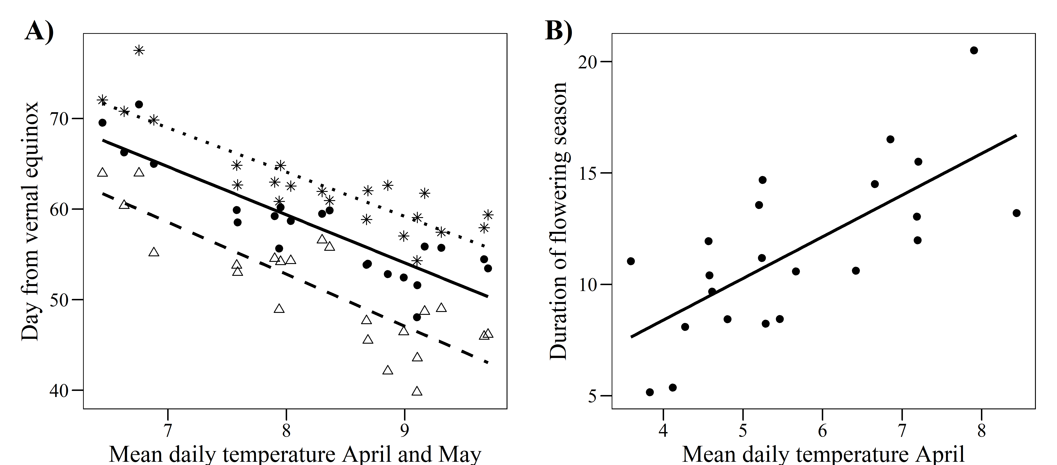
Figure 3: Relationships among linear selection gradients for first flowering day and (A) spring temperature, measured as mean daily temperature in April and May, (B) position of the flowering season, measured as the day when 10% of the plants had started flowering (triangles and dashed line), the mean first flowering day (points and solid line) and day the when 90% of the plants had started flowering (stars and dotted line), all of them calculated as the number of days from the vernal equinox, and (C) duration of the flowering season, measured as the number of days between the day when 10% of the plants had started flowering and the day when 90% of the plants had started flowering. Black lines represent linear model fits (non-significant). Grey dashed lines indicate a selection gradient of 0.
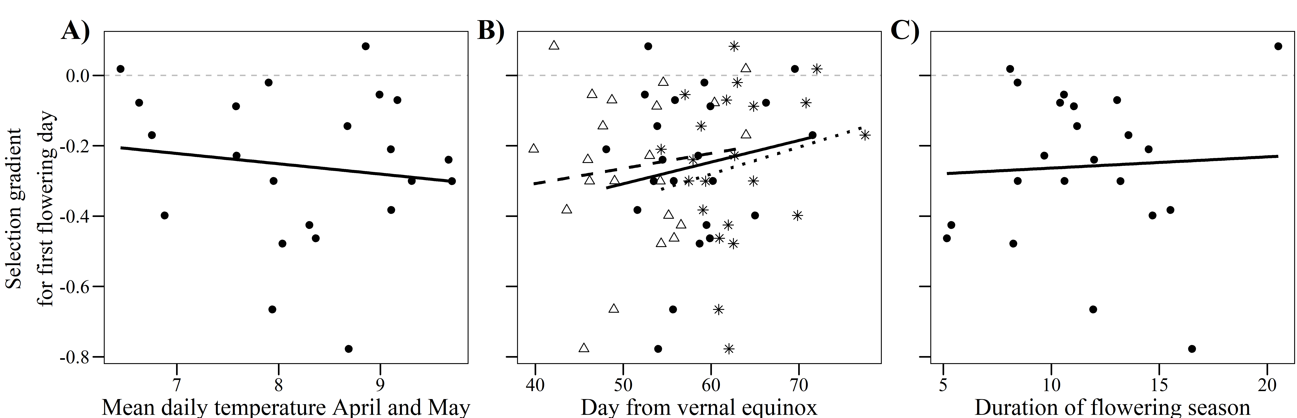
Supplementary Material
Table S1: Phenotypic selection differentials and standard errors for first flowering day and number of flowers in Lathyrus vernus on 22 study years. Values in bold are significant at α = 0.05.
Year | First flowering day |  | First flowering day² |  | Number of flowers |  | Number of flowers²
Year | Estimate | SE | Estimate | SE | Estimate | SE | Estimate | SE
1987 | -0.372 | 0.092 | -0.054 | 0.076 | 0.766 | 0.081 | -0.012 | 0.043
1988 | -0.302 | 0.106 | -0.060 | 0.067 | 0.541 | 0.101 | 0.002 | 0.066
1989 | -0.609 | 0.128 | 0.134 | 0.099 | 0.846 | 0.113 | 0.054 | 0.099
1990 | -0.469 | 0.162 | 0.120 | 0.105 | 0.681 | 0.156 | -0.448 | 0.069
1991 | -0.662 | 0.078 | 0.174 | 0.072 | 0.695 | 0.076 | 0.038 | 0.058
1992 | -0.438 | 0.183 | 0.028 | 0.155 | 0.114 | 0.187 | -0.522 | 0.106
1993 | -0.428 | 0.133 | -0.078 | 0.105 | 0.436 | 0.133 | -0.220 | 0.085
1994 | -0.429 | 0.180 | 0.056 | 0.150 | 0.449 | 0.180 | -0.198 | 0.090
1995 | -0.147 | 0.241 | -0.348 | 0.247 | 0.364 | 0.236 | -0.260 | 0.125
1996 | -0.373 | 0.106 | -0.178 | 0.089 | 0.642 | 0.095 | -0.156 | 0.070
2006 | -0.396 | 0.135 | 0.150 | 0.073 | 0.611 | 0.126 | -0.484 | 0.045
2007 | -0.425 | 0.111 | 0.180 | 0.097 | 0.283 | 0.116 | -0.270 | 0.053
2008 | -0.512 | 0.121 | 0.328 | 0.063 | 0.769 | 0.102 | -0.204 | 0.057
2009 | -0.215 | 0.269 | -0.406 | 0.234 | 0.304 | 0.267 | -0.474 | 0.120
2010 | -0.492 | 0.164 | 0.282 | 0.142 | 0.280 | 0.170 | -0.600 | 0.109
2011 | -0.709 | 0.196 | 0.382 | 0.134 | 0.924 | 0.185 | 0.072 | 0.130
2012 | -1.035 | 0.187 | 1.120 | 0.138 | 1.054 | 0.186 | -0.358 | 0.110
2013 | -0.425 | 0.322 | 0.006 | 0.303 | 0.083 | 0.326 | -0.370 | 0.322
2014 | -0.668 | 0.173 | 0.354 | 0.143 | 0.252 | 0.191 | -0.444 | 0.091
2015 | 0.048 | 0.231 | -0.846 | 0.237 | -0.003 | 0.231 | -0.544 | 0.161
2016 | -0.351 | 0.096 | 0.016 | 0.068 | 0.606 | 0.083 | -0.124 | 0.066
2017 | 0.282 | 0.497 | -0.250 | 0.250 | -0.541 | 0.496 | 0.312 | 0.350

Table S2: Phenotypic selection gradients and standard errors for first flowering day and number of flowers in Lathyrus vernus on 22 study years. Values in bold are significant at α = 0.05.
Year | First flowering day |  | First flowering day² |  | First flowering day  x Number of flowers
Year | Estimate | SE | Estimate | SE | Estimate | SE
1987 | -0.078 | 0.088 | -0.142 | 0.085 | 0.010 | 0.180
1988 | -0.088 | 0.111 | 0.182 | 0.075 | 0.578 | 0.179
1989 | -0.144 | 0.143 | 0.070 | 0.134 | 0.061 | 0.225
1990 | -0.240 | 0.169 | -0.098 | 0.120 | -0.352 | 0.278
1991 | -0.398 | 0.087 | 0.078 | 0.086 | 0.122 | 0.165
1992 | -0.463 | 0.199 | 0.192 | 0.184 | 0.172 | 0.252
1993 | -0.300 | 0.144 | 0.042 | 0.119 | 0.153 | 0.194
1994 | -0.300 | 0.194 | -0.036 | 0.171 | -0.081 | 0.236
1995 | 0.018 | 0.266 | -0.458 | 0.308 | -0.154 | 0.443
1996 | -0.170 | 0.101 | -0.098 | 0.093 | -0.006 | 0.139
2006 | -0.228 | 0.132 | 0.226 | 0.075 | 0.360 | 0.210
2007 | -0.383 | 0.131 | 0.486 | 0.150 | 0.394 | 0.266
2008 | -0.210 | 0.112 | 0.146 | 0.067 | -0.096 | 0.246
2009 | -0.070 | 0.321 | -0.126 | 0.303 | 1.285 | 0.794
2010 | -0.478 | 0.195 | 0.392 | 0.165 | 0.379 | 0.358
2011 | -0.301 | 0.218 | 0.104 | 0.171 | -0.318 | 0.507
2012 | -0.665 | 0.210 | 0.740 | 0.187 | -0.335 | 0.430
2013 | -0.426 | 0.331 | 0.356 | 0.362 | 0.455 | 0.449
2014 | -0.777 | 0.211 | 0.680 | 0.207 | 0.315 | 0.351
2015 | 0.083 | 0.315 | -1.950 | 0.364 | -1.041 | 0.555
2016 | -0.055 | 0.097 | 0.010 | 0.076 | 0.500 | 0.189
2017 | -0.020 | 0.595 | -0.412 | 0.406 | -0.006 | 0.759

Figure S1: Linear (A) and quadratic (B) phenotypic selection differentials and standard errors for first flowering day (black) and number of flowers (grey) in Lathyrus vernus on 22 study years. Circles represent the estimates (filled circles are significant estimates at α = 0.05) and bars represent the standard errors.
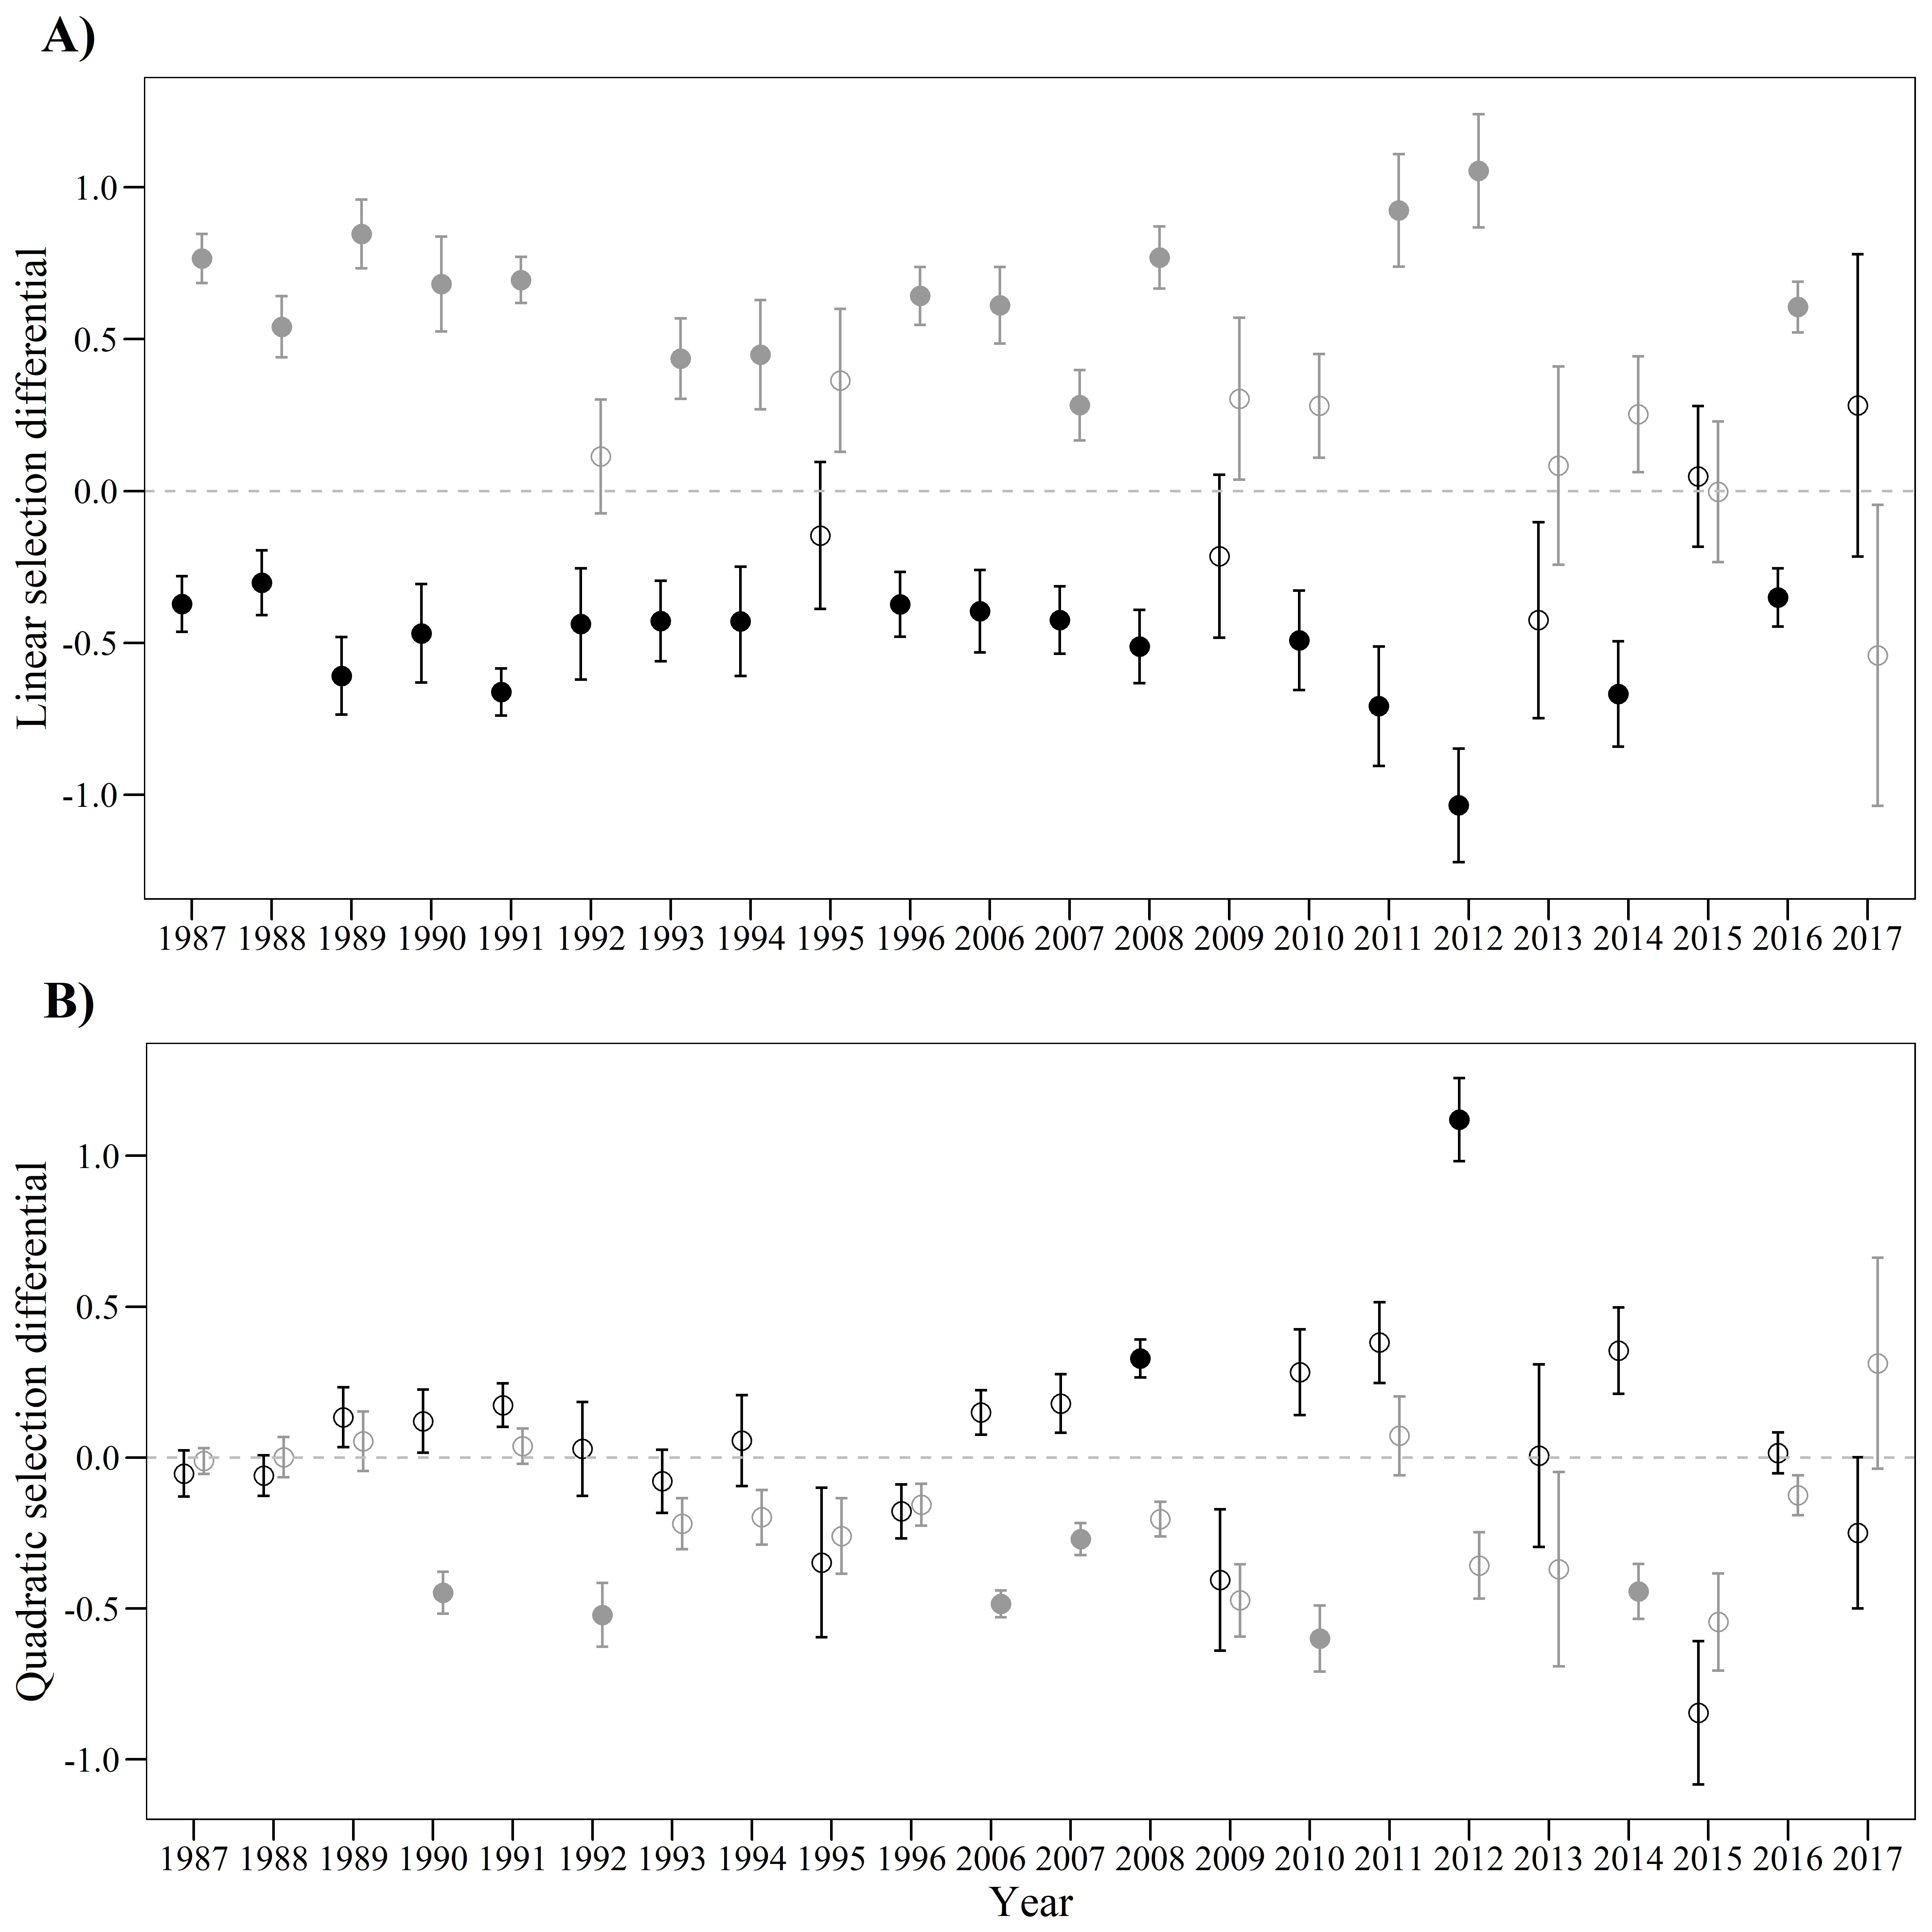
Figure S1 (alternative 1): Relationships among relative number of intact seeds and standardized first flowering day (calculated as the number of days from the vernal equinox) and number of flowers in Lathyrus vernus on 22 study years (represented with different colors). Linear (A) and quadratic (B) model fit lines are shown. The slopes of the lines represent the phenotypic selection differentials.
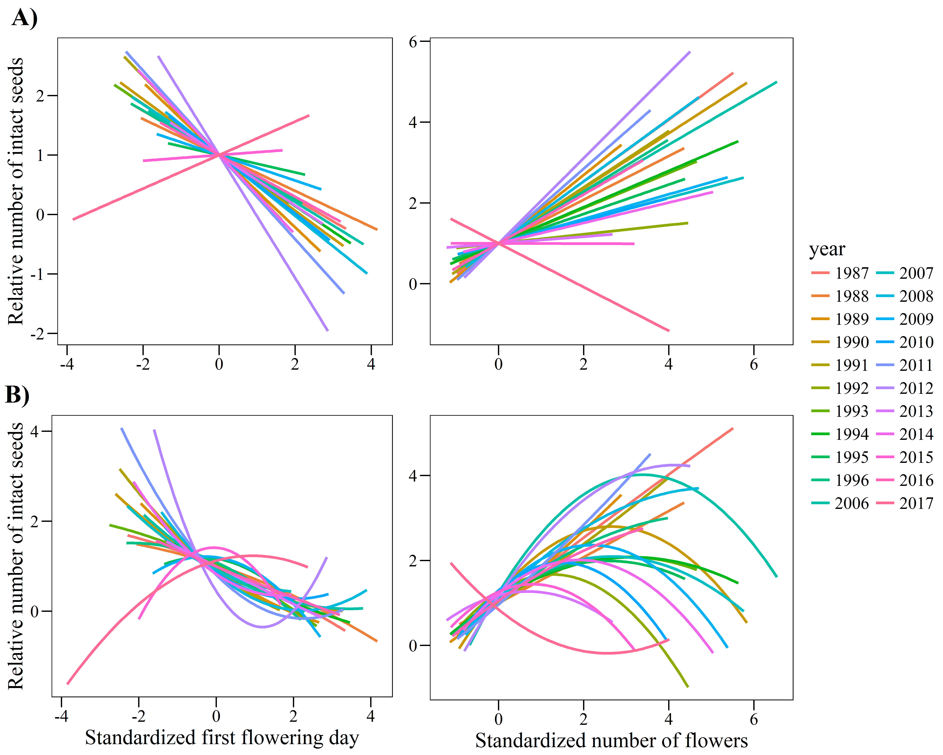

Figure S1 (alternative 2):
(A) Relationships among relative number of intact seeds and standardized first flowering day (calculated as the number of days from the vernal equinox) in Lathyrus vernus on 22 study years. Linear (black) and quadratic (blue) model fit lines are shown with their standard errors. The slopes of the lines represent the phenotypic selection differentials.
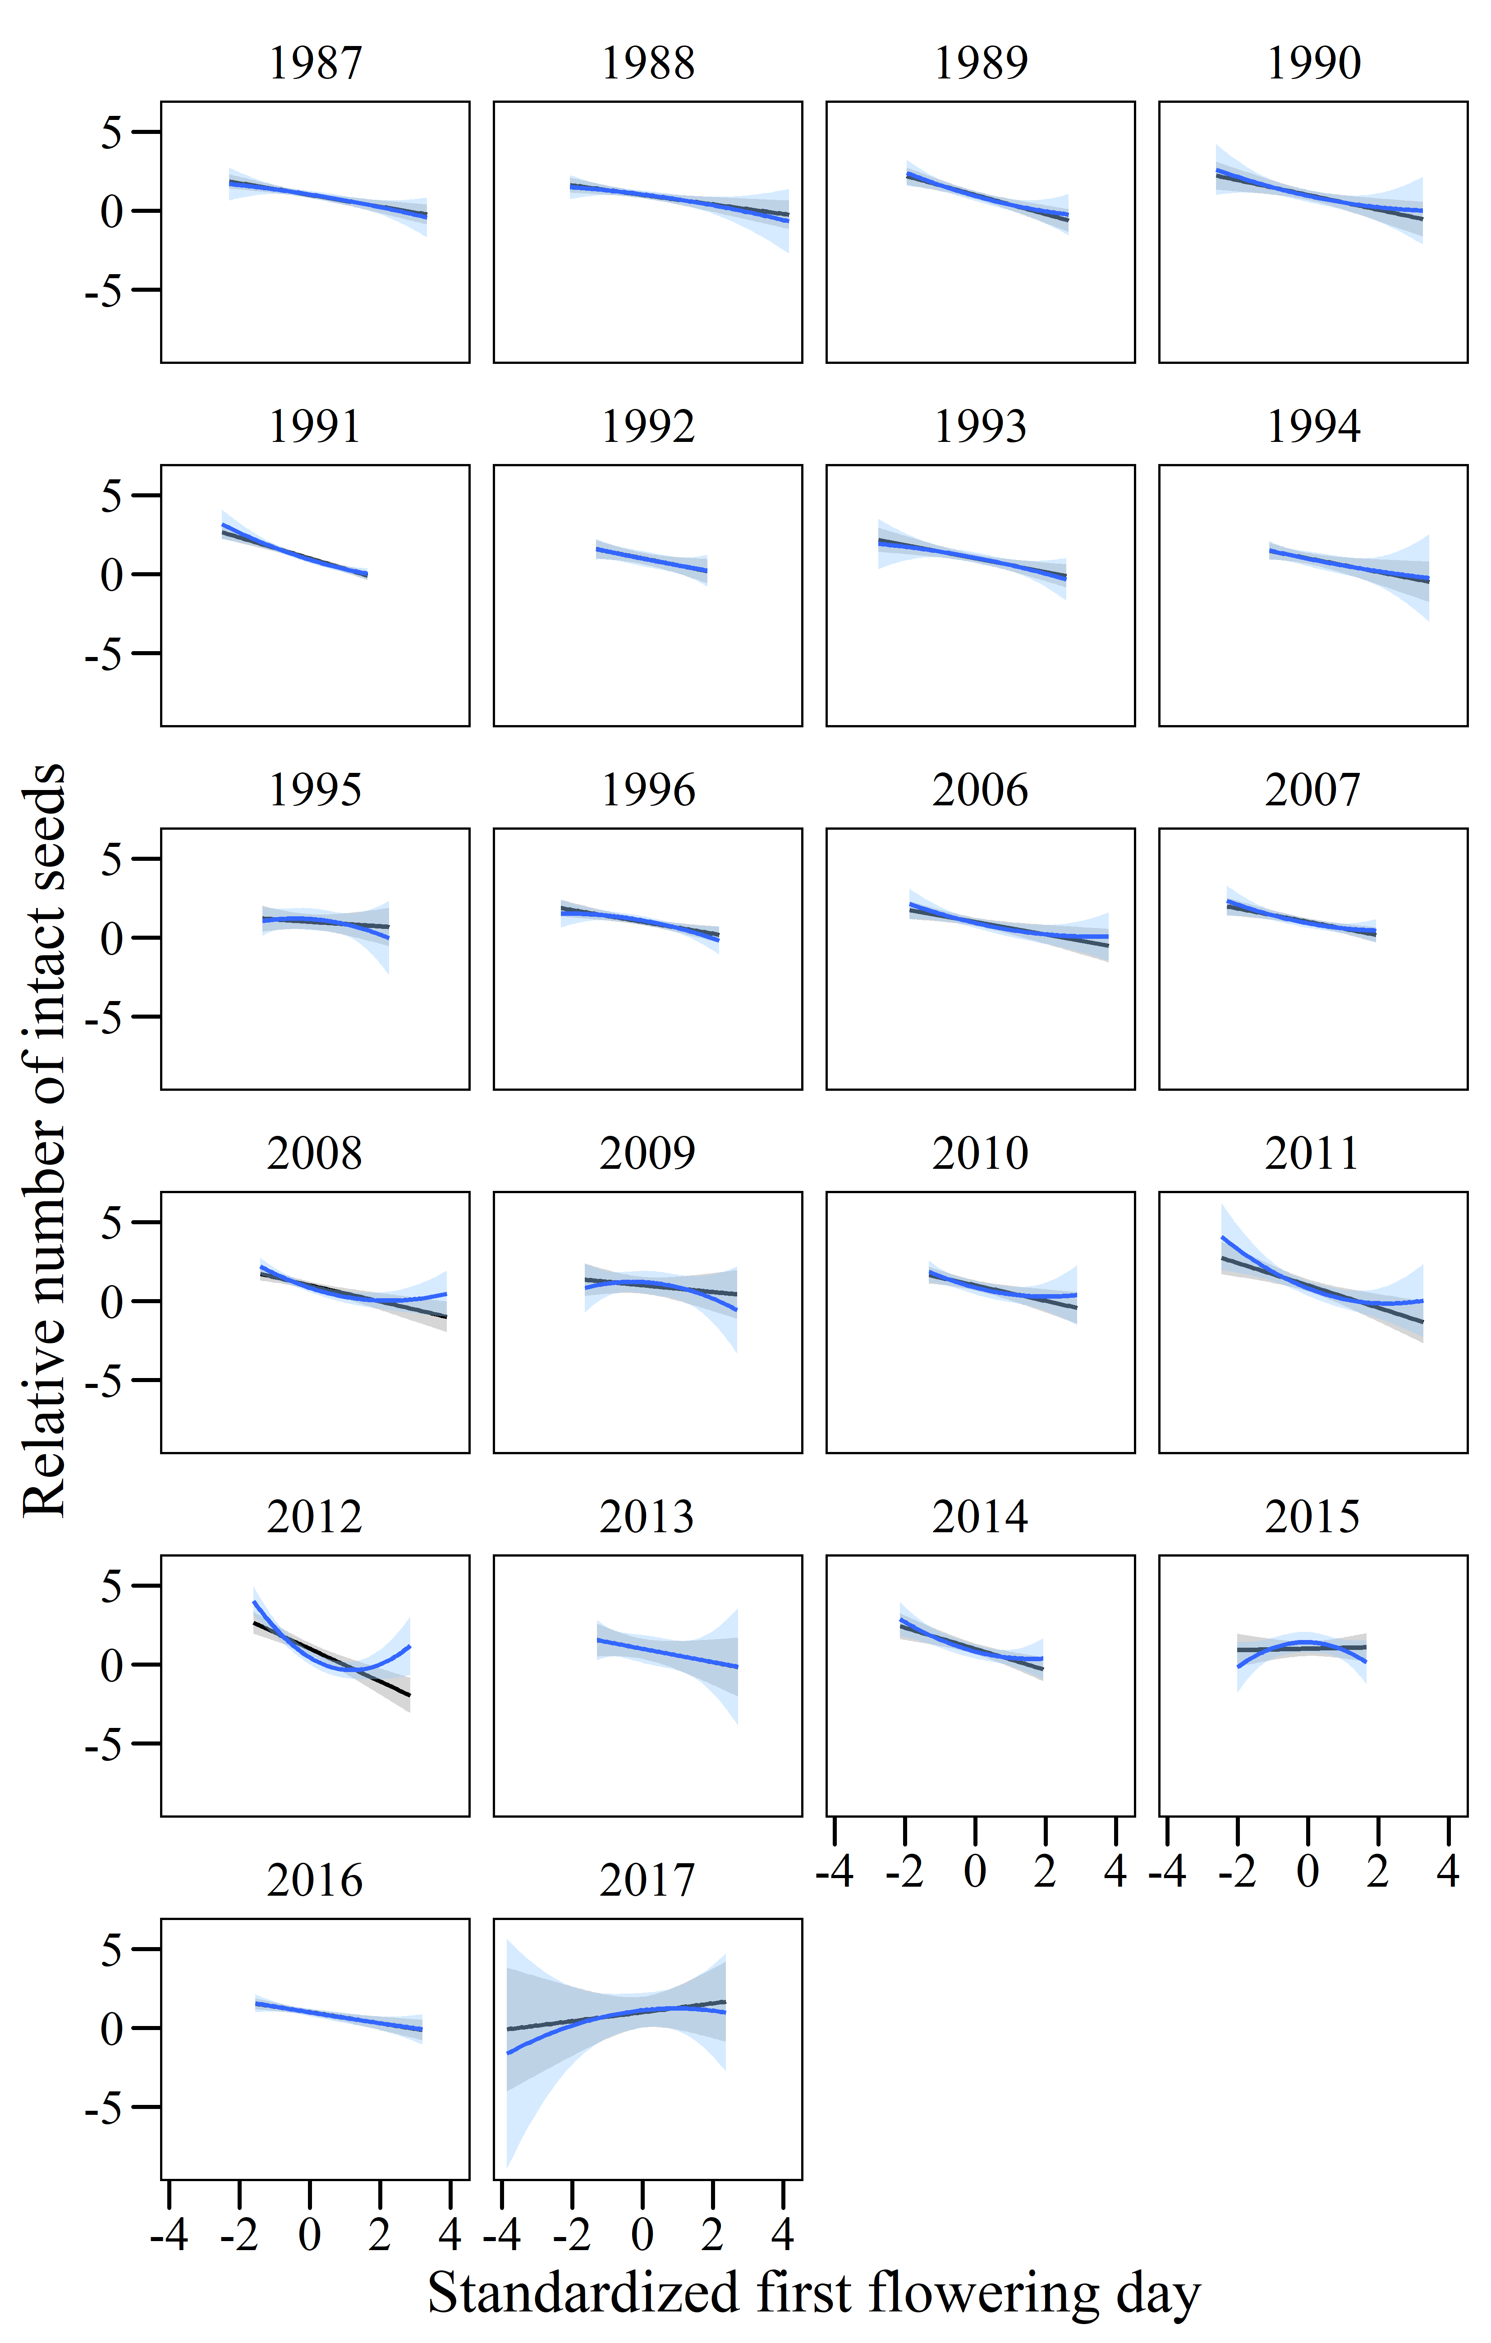
(B) Relationships among relative number of intact seeds and standardized number of flowers in Lathyrus vernus on 22 study years. Linear (black) and quadratic (blue) model fit lines are shown with their standard errors. The slopes of the lines represent the phenotypic selection differentials.
